**Service Applications in SharePoint**

Services that are running in background for the user activities and operations.

Service Applications in SharePoint are associated with web applications, and specific services are typically deployed as needed in a particular farm. Only deployed services are referred to as service applications. This is a huge advantage in terms of conserving resources and optimizing performance. For instance, a specific web application can be configured to use only the services it needs. The number of service applications that exist is vast, and, as third-party vendors can create their own services for SharePoint Server. A list of services are:

* Access Services
* [APP Management Service](https://social.technet.microsoft.com/wiki/contents/articles/12516.sharepoint-2013-app-management-service.aspx)
* [Business Data Connectivity Service](https://docs.microsoft.com/en-us/sharepoint/administration/business-connectivity-services-overview)
* [Machine Translation Service](https://docs.microsoft.com/en-us/sharepoint/dev/general-development/machine-translation-services-in-sharepoint)
* [Managed Metadata Service](https://docs.microsoft.com/en-us/sharepoint/governance/managed-metadata-planning)

***A Managed Metadata column is a special kind of column that you can add to lists or libraries****. It enables site users to select terms from a specific term set. A Managed Metadata column can map to an existing term set, or you can create a local term set specifically for the column.*

* [PerformancePoint Service Application](https://docs.microsoft.com/en-us/sharepoint/administration/performancepoint-services-overview)
* [Project Server Service Application](https://docs.microsoft.com/en-us/project/install-and-configure-project-server-2016)
* [Search Service Application](https://docs.microsoft.com/en-us/sharepoint/search/search)

*Search Service Application provides the enterprise search functionality to one or more SharePoint farms. It provides mechanisms to index SharePoint and non-SharePoint content sources, query the indexed data and provide search results, where required. The search architecture contains search components and databases.*

* [Secure Store Service](https://docs.microsoft.com/en-us/sharepoint/administration/configure-the-secure-store-service)
* [User Profile Service Application](https://docs.microsoft.com/en-us/sharepoint/administration/user-profiles-and-identities)

*The User Profile service stores information about users in a central location. It enables My Sites, social computing features such as social tagging and newsfeeds, and creating and distributing profiles across multiple sites and farms.*

* Visio Graphics Service
* Word Automation Services

We can set up a single service application to be shared among multiple web applications or deploy multiple instances of the same service across a farm and, in some cases, across multiple farms. Also, there is no limitation regarding the number of services that can be deployed in any single farm.

* Business Data Connectivity
* Machine Translation
* Managed Metadata
* User Profile
* Search
* Secure Store

Navigate to “Central Admin -> Application Management ->Manage Service Applications” and click on “New” from ribbon to see the list of service applications available.

[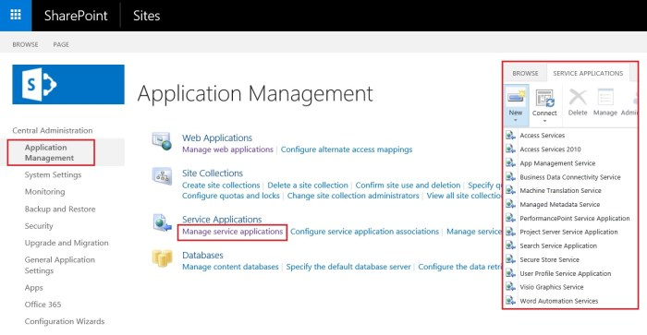](https://i0.wp.com/sharepointtechnicalsupport.com/wp-content/uploads/2018/10/Service-Applications-in-SharePoint-1300x674.jpg?ssl=1)

## SharePoint services 2016

For every service application there is a service associated with it which we can from central admin by navigating to “Central Admin -> Application Management -> Manage Services on Server”.

[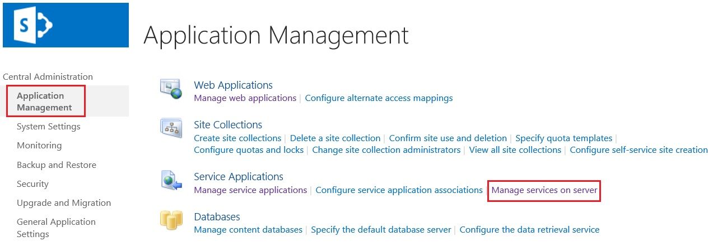](https://i0.wp.com/sharepointtechnicalsupport.com/wp-content/uploads/2018/10/manage-services-on-server-1273x441.jpg?fit=1273%2C441&ssl=1)[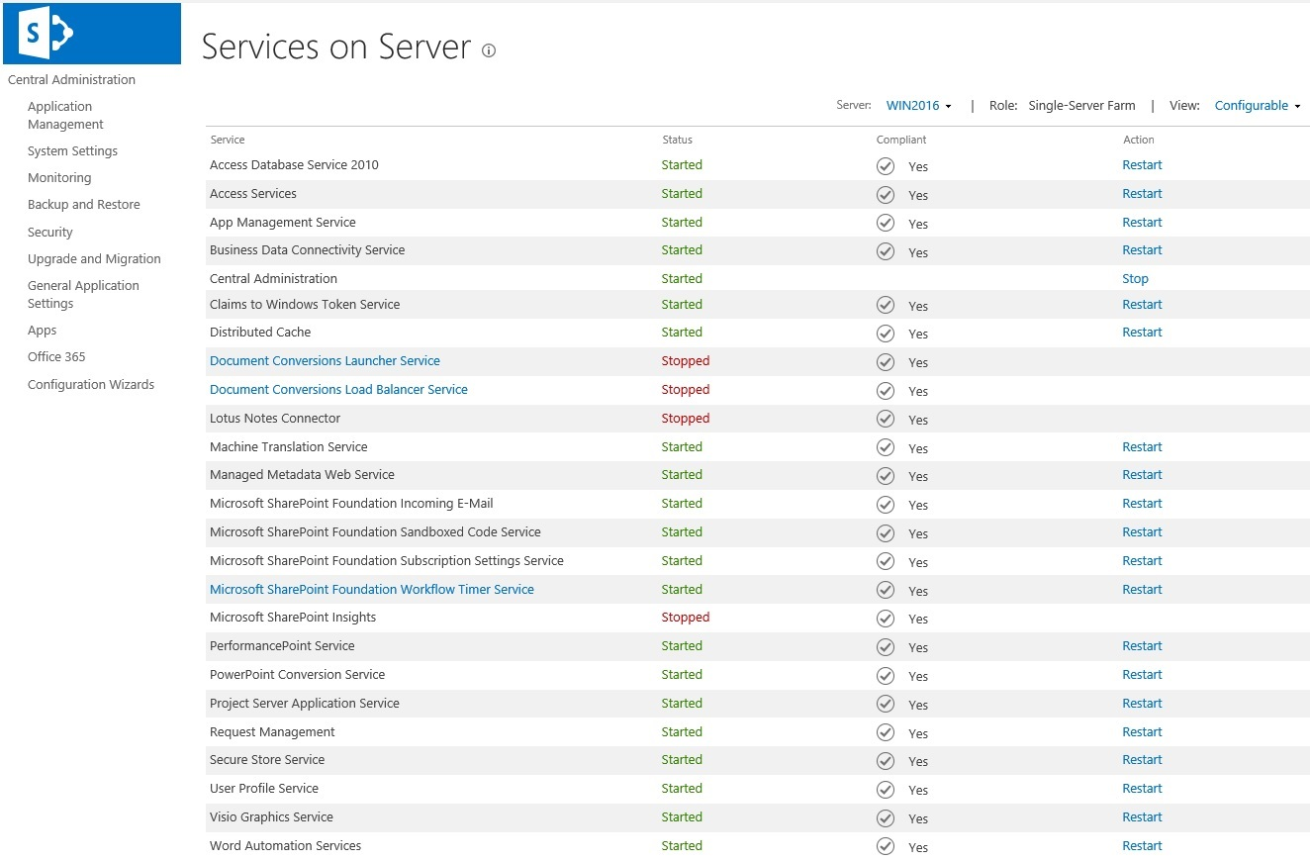](https://i1.wp.com/sharepointtechnicalsupport.com/wp-content/uploads/2018/10/services-on-server-1324x870.jpg?fit=1324%2C870&ssl=1)

SharePoint Server includes a set of service applications that we can use to share services across web applications. In some cases, we can also share service applications across farms. We can manage service applications by using the SharePoint Central Administration website or by using Windows PowerShell 3.0.